First Presbyterian Church

104 So. 10th St., Norfolk, NE 68701
Phone: 402-371-1635

March 19, 2023

Mission Statement

“Proclaiming the Love of Christ
in the Heart of Norfolk
Since 1896”
Order of Worship
Sunday Worship, March 19, 2023
Fourth Sunday in Lent
First PC, Norfolk, NE

Prelude

Leader: The grace of the Lord Jesus Christ be with you all!
People: And also with you.

Welcome and Announcements

Passing of the Peace:
Signing in American Sign Language (ASL)

Leader: The peace of the Lord Jesus Christ be with you all!
People: And also with you.

Call to Worship
Leader: The Lord is my shepherd; I shall not be in want.
People: He makes me lie down in green pastures, he
leads me beside quiet waters, he restores my
soul.
Leader: He guides me in the paths of righteousness for his
name’s sake.
People: Even though I walk through the valley of the
shadow of death, I will fear no evil,
Leader: for you are with me; your rod and your staff, they
comfort me.
People: You prepare a table before me in the presence
of my enemies.
Leader: You anoint my head with oil; my cup overflows.
People: Surely goodness and love will follow me all the
days of my life, and I will dwell in the house of the Lord forever.
-- Psalm 23
Song (video) “Open the Eyes of My Heart, Lord”

Call to Confession

The proof of God’s amazing love is this: While we were sinners Christ died for us. Because we have faith in him, we dare to approach God with confidence. In faith and penitence, let us confess our sin before God and one another.

Prayer of Confession

God of mercy, you sent Jesus Christ to seek and save the lost. We confess that we have strayed from you and turned aside from your way. We are misled by pride, for we see ourselves pure when we are stained, and great when we are small. We have failed in love, neglected justice, and ignored your truth. Have mercy, O God, and forgive our sin. Return us to paths of righteousness through Jesus Christ, our Savior.

(We observe a time of silence for personal confession.)

Assurance of Pardon

Leader: Friends, hear the Good News! Though you once
were all darkness, now as Christians you are light.
People: Though we once were darkness, now as
Christians we are light.
Leader: Friends, believe the Good News!
People: In Jesus Christ, we are forgiven.

Response (579) “Glory to the Father (Gloria Patri)”

Choir Anthem “I Saw the Light”
(Insert)

The Word

Scripture: John 9:1-12, 24-41
Message “Seeing Is Believing” Pastor Brian

Hymn of Response (394) “There is a Balm in Gilead”

Offering our Gifts/Offertory

Response (592) “Praise God, from Whom All Blessings Flow”
(Doxology)

Call to Prayer (insert)
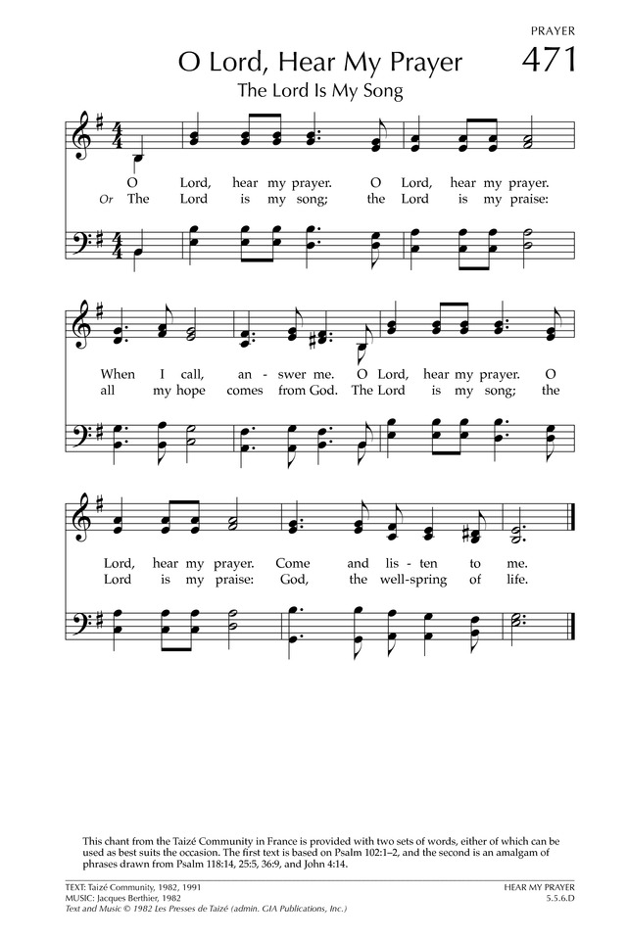

Prayers of the People/Lord’s Prayer

Our Father who art in heaven, hallowed be thy name.
Thy Kingdom come, thy will be done, on earth as it is in heaven.
Give us this day our daily bread;
and forgive us our debts, as we forgive our debtors;
and lead us not into temptation, but deliver us from evil. For thine is the kingdom, and the power and the glory, forever.

Final Hymn (280) “Amazing Grace, How Sweet the Sound”

Blessing and Sending

Postlude

We are glad you chose to spend your Sunday morning with us, and we encourage you to return!

Children of all ages are welcome in worship. Children’s worship materials are available from the book cart. A Cry Room is located at the back of the sanctuary.

MAUNDY THURSDAY, APRIL 6, 2023
6:00 PM - SUPPER, 7:00 PM – WORSHIP

First Presbyterian will commemorate Maundy Thursday with a light Mediterranean style supper at 6:00 p.m. in the Fellowship Hall. Worship will begin at 7:00 p.m. in the Sanctuary. At this time, a foot washing enactment (voluntary) is also being planned. Communion will be celebrated during the worship service. Please sign up if you plan to attend the meal. If you would like to make a food contribution, write that down beside your name. Please complete the sign-up by Sunday, April 2. We welcome this opportunity to worship and fellowship together in celebration of the events of Holy Week.

As we approach the culmination of our Lenten journey, Norfolk Chamber Singers will present The Cross, The Crown, which will focus on the solemnity of Holy Week through sacred word and song. Please join us at St. Mary's Catholic Church on Palm Sunday, April 2, 2023, 7:00 p.m. No admission will be charged, but a freewill offering will be gathered.

Easter Lilies are a joyful symbol of elegance, beauty, spirituality, hope, and life. If you would like to order an Easter Lily in memory or honor of someone special, please fill out a form (on table in narthex) and enclose payment of $16 (per plant) in an envelope. You can put your order and money in the offering plate on Sunday or mail or hand deliver to the church office by Friday, Mar. 24th. The lilies will adorn our sanctuary on Easter Sunday; then you can choose to take yours or donate to the Deacons to deliver to shut-ins as part of their caring ministry.

Session is considering a Loop System in the sanctuary to further help those of us who use hearing aids. Before we do, we would like to know if the new sound system is working for you and if the loop system is necessary. Please let Pat McCollough know in the next two months how the new system is working for you. Thanks.

The Deacons Project for March is Mercy Meals. Mercy Meals of Nebraska works in conjunction with the Orphan Grain Train to pack and distribute nourishing food to children throughout the world. By volunteering one hour of your time you can provide enough food to feed a child for one year. Working together we can make a difference.

Birthdays

Erin Beckenhauer 3/19
Tate Teidtke 3/19
Laura Walter 3/21
Linda Unkel 3/22
Leon Northouse 3/26
Wongani Mtika 3/28
Ed McClymont 3/30

Anniversaries

Dennis & Kathy Sateren 3/19

Prayers for God’s Children

For healing and pain relief for those living with physical and emotional pain and for their families and friends

For our members who are home-bound or in nursing facilities

For our mission partners
For the men and women serving in our armed forces

This Week at First Pres
Today: 10:00 AM – Worship
Monday: 8:30 AM – 10:00 AM N/A (fellowship hall)
Tuesday: 9:45 AM – Meadows/BelAir Communion
8:00 PM – 9:30 PM N/A (fellowship hall)
Wednesday: 8:30 AM – 10:00 AM N/A (fellowship hall)
2:00 PM – Bulletin Information Deadline
6:45 PM – Choir Rehearsal
Thursday: 8:30 AM – 10:00 AM N/A (fellowship hall)
5:30 PM – 7:00 PM TOPS (fellowship hall

Next Sunday at First Pres
10:00 AM – Worship
10:00 AM – Good Morning, Good News

Elders Deacons
Class of 2023 Class of 2023
Dennis Sateren, Missions Linda Douglas, Co-Moderator
David Unkel, Personnel Karen Reimer
Barb Beckmann,Worship/Cong.
Class of 2024 Class of 2024
Kathy Naranjo, Worship/Cong. Mark Johnson, Co-Moderator
Linda Cox, Clerk of Session Sherry Johnson, Treasurer
Jayne Mtika
Class of 2025 Class of 2025
Teri Wendel, Christian Ed. Shelley Dahl, Secretary
Dave Gerharter, Finance Joyce Zittritsch
Pat McCollough, Properties Sonja Jones

Elders of the Month – Barb Beckmann & Dennis Sateren

2022 YTD Financials – through December 31st, 2022
Receipts $121,234.86 – Disbursements $194,719.22 = Net ($68,684.19)
Attendance 58

Worship Leaders & Staff

PASTOR Rev. Brian Johnson
MUSIC DIRECTOR Greta Johnson ORGANIST Steve Reinke
SOUND TEAM Joe Mtika, Barb Beckmann
PRAISE TEAM Kim Rusk, Brynn Rusk Joe Mtika
LAY READER Barb Beckmann
Credits: “Open the Eyes of Heart, Lord” by Mercy Me
is used under CCLI license #1820283.

Office hours: 9 am to 1 pm Mon.
9 am to 4 pm Tues. – Thur.
9 am to 1 pm Fri.
or other times by appointment
E-Mail: FirstPresB@ConPoint.com
Website: firstpresnorfolk.com
‘Like’ us on Facebook: First Pres – Norfolk, NE

