First Presbyterian Church

104 So. 10th St., Norfolk, NE 68701
Phone: 402-371-1635 Fax: 402-371-0135

October 2, 2022

Order of Worship
Sunday Worship, October 2, 2022
Seventeenth Sunday after Pentecost
World Communion Sunday
First PC, Norfolk, NE

Prelude

Leader: The grace of the Lord Jesus Christ be with you all!
People: And also with you.

Welcome and Announcements

Passing of the Peace:
Signing in American Sign Language (ASL)

Leader: The peace of the Lord Jesus Christ be with you all!
People: And also with you.

Call to Worship
Leader: Do not fret because of evil doers, or be envious of
those who do wrong;
People: for like the grass, they will soon wither, like
green plants they will soon die away.
Leader: Trust in the Lord and do good;
People: dwell in the land and enjoy safe pasture.
Leader: Delight yourself in the Lord
People: and God will give you the desires of your heart.
Leader: Refrain from anger and turn away from wrath;
People: do not fret – it leads only to evil.
Leader: For evil doers will be cut off,
People: but those who hope in the Lord will inherit the
land. -- Psalm 37:1-4,8-9

Opening Song (video) “Ancient Words”
Call to Confession

Remember that our Lord Jesus can sympathize with us in our weaknesses, since in every respect he was tempted as we are, yet without sin. Let us then with boldness approach the throne of grace, that we may receive mercy and find grace to help in time of need. Let us confess our sins against God and our neighbor.

Prayer of Confession

Almighty and merciful God, we have erred and strayed from your ways like lost sheep. We have followed too much the devices and desires of our own hearts. We have offended against your holy laws. We have left undone those things which we ought to have done; and we have done those things which we ought not to have done. O Lord, have mercy upon us. Spare those who confess their faults. Restore those who are penitent, according to your promises declared to the world in Christ Jesus our Lord. And grant, O merciful God, for his sake, that we may live a holy, just, and humble life to the glory of your holy name.

(We observe a time of silence for personal confession.)

Assurance of Pardon

Leader: Friends, hear the Good News! Our eternal
salvation has been brought fully into view by the
appearance on earth of our Savior, Jesus Christ.
People: Jesus Christ has broken the power of death and
brought immortality to light through the gospel.
Leader: Friends, believe the Good News!
People: In Jesus Christ, we are forgiven.
Response (579) “Glory to the Father (Gloria Patri)”

Choir Anthem “Out of Love, He Broke the Bread”
(insert)
The Word
Children’s Message
Scripture: Ephesians 4:1-16
Message “Unity in the Church” Pastor Brian

Song of Response (video) “They’ll Know We Are
Christians by our Love”
Offering/Offertory

Response (592) “Praise God, from Whom All Blessings Flow”
(Doxology)

Call to Prayer (insert) “Holy Spirit, Come to Us”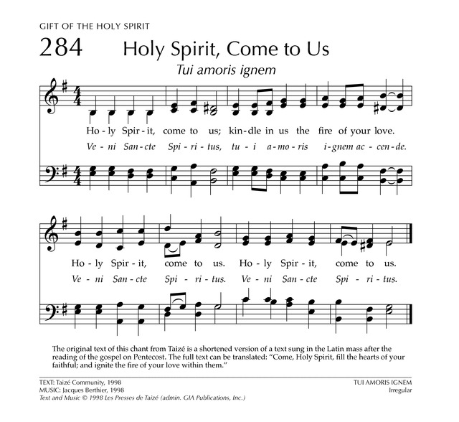
Prayers for Our Sister Church (insert)

Prayers of the People/Lord’s Prayer

Our Father who art in heaven, hallowed be thy name.
Thy Kingdom come, thy will be done, on earth as it is in heaven.
Give us this day our daily bread;
and forgive us our debts, as we forgive our debtors;
and lead us not into temptation, but deliver us from evil. For thine is the kingdom, and the power and the glory, forever.

Communion Song (514) “Let Us Talents and
Tongues Employ”
Communion
Invitation to the Table
Prayer
Words of Institution
Sharing of the Sacrament

Blessing and Sending

Postlude

We are glad you chose to spend your Sunday morning with us, and we encourage you to return!

Children of all ages are welcome in worship. Children’s worship materials are available from the book cart. A Cry Room is located at the back of the sanctuary.

The Mission Candle is lit by Ann Letheby in loving memory of her Dad, Earl Letheby (June 26, 1925 to September 30,1986)

Pack-A-Way Hunger is this Sunday Oct. 2 at 2:00pm @ the Mercy Meals building, 603 Madison Ave. There is still room for volunteers. Everyone is welcome.

Life Chain 2022. Join hundreds of pro-lifers on National Life Chain this afternoon from 2:00pm-3:00pm as we line the sidewalks of 13th St. in Norfolk to form a life chain.

The Deacon’s Mission Giving Project for October is A.R.C. of Norfolk. ARC is a non-profit, parent-driven membership organization that advocates for the rights of citizens with developmental disabilities and their families
in Northeast Nebraska.

Peace and Global Witness Offering 2022. Embrace the
reconciling peace of Jesus Christ and bear witness to that peace, by giving to the Peace and Global Witness offering. 25% of the offering stays with FPC - Norfolk, to support peacemaking in the Norfolk community. 25% of the offering stays with our mid council to support peacemaking in our region. 50% of the offering supports ministries of peace
and reconciliation being done by Presbyterians across the globe.

Birthdays

Bev Henkel 10/02
Linda Cox 10/04
Makenzie Jones 10/04
Norm Winder 10/09
Carolyn Brower 10/12
Katie Lackas 10/12
Charles Sintek 10/13
Lori Burns 10/14

Anniversaries

Jim & Joyce Zittritsch 10/03
Don & Lori Burns 10/13

Prayers for God’s Children

For healing and pain relief for those living with physical and emotional pain and for their families and friends

For our members who are home-bound or in nursing facilities.

For our mission partners.

For the men and women serving in our armed force

This Week at First Pres

Today: 10:00 AM – Worship
Monday: 8:30 AM – 10:00 AM N/A (fellowship hall)
Tuesday: 8:00 PM – 9:30 PM N/A (fellowship hall)
Wednesday: 8:30 AM – 10:00 AM N/A (fellowship hall) 2:00 PM – Bulletin Information Deadline
6:45 PM – Choir Rehearsal
Thursday: 8:30 AM – 10:00 AM N/A (fellowship hall)
5:30 PM – 7:00 PM TOPS (fellowship hall)

Next Sunday at First Pres

10:00 AM – Worship
10:00 AM – Good Morning, Good News

Elders Deacons
Class of 2022 Class of 2022
Teri Wendel, Christian Ed. Kerry Richter
Jake Cox, Properties Karen Reimer
Greg Wendel, Secretary
Class of 2023 Class of 2023
Dennis Sateren, Missions Linda Douglas, Co-Moderator
David Unkel, Personnel Ann Letheby, Treasurer
Barb Beckmann, Worship/Cong. Class of 2024
Class of 2024 Mark Johnson, Co-Moderator
Kathy Naranjo, Worship/Cong. Sherry Johnson
Linda Cox, Clerk of Session Jayne Mtika

Elders of the Month – Jake Cox & Linda Cox
__________________________________________________________2022 YTD Financials - through April 30th, 2022
Receipts $55,282.54 - Disbursements $63,931.79 = Net ($8,649.25)
Last Sunday Attendance 40

Worship Leaders & Staff

PASTOR Rev. Brian Johnson
MUSIC DIRECTOR Greta Johnson ORGANIST Steve Reinke
SOUND TEAM Joe Mtika, Barb Beckman
PRAISE TEAM Kim Rusk, Joe Mtika
LAY READER Ann Letheby

Credits: “Ancient Words” by Robin Mark, “They’ll Know We Are Christians by our Love” by Carolyn Arends
is used under CCLI license #1820283.

Office hours: 9 am to 1 pm Mon.
9 am to 4 pm Tues. – Thur.
9 am to 1 pm Fri.
or other times by appointment

E-Mail: FirstPresB@ConPoint.com
Website: firstpresnorfolk.com
‘Like’ us on Facebook: First Pres – Norfolk, NE

