First Presbyterian Church

104 So. 10th St., Norfolk, NE 68701
Phone: 402-371-1635 Fax: 402-371-0135

July 31, 2022

Order of Worship
Sunday Worship, July 31, 2022
Eighth Sunday after Pentecost
First PC, Norfolk, NE

Prelude

Leader: The grace of the Lord Jesus Christ be with you all!
People: And also with you.

Welcome and Announcements

Passing of the Peace:
Signing in American Sign Language (ASL)

Leader: The peace of the Lord Jesus Christ be with you all!
People: And also with you.

Call to Worship
Leader: Give thanks to the Lord, for God is good;
People: God’s love endures forever.
Leader: Let the redeemed of the Lord say this –
People: those God redeemed from the hand of the foe,
Leader: those God gathered from the lands,
People: from east and west, from north and south.
Leader: Let them give thanks to the Lord for his unfailing
love
People: and his wonderful deeds for humanity.
-- Psalm 107:1-3,8

Opening Song (video)
“Amazing Grace (My Chains Are Gone)”

Call to Confession

Remember that our Lord Jesus can sympathize with us in our weaknesses, since in every respect he was tempted as we are, yet without sin. Let us then with boldness approach the throne of grace, that we may receive mercy and find grace to help in time of need. Let us confess our sins against God and our neighbor.

Prayer of Confession

Gracious God, our sins are too heavy to carry, too real to hide, and too deep to undo. Forgive what our lips tremble to name, what our hearts can no longer bear, and what has become for us a consuming fire of judgment. Set us free from a past that we cannot change; open to us a future in which we can be changed; and grant us grace to grow more and more in your likeness and image; through Jesus Christ, the light of the world.

(We observe a time of silence for personal confession.)

Assurance of Pardon

Leader: Friends, hear the Good News! All who declare
Christ as Lord have died with Christ to sin and their lives are hidden with Christ in God.
People: When Christ who is our life is manifested, then
we too will be manifested with him in glory.
Leader: Friends, believe the Good News!
People: In Jesus Christ, we are forgiven.

Response (579) “Glory to the Father (Gloria Patri)”

Special Music Sherry Johnson

The Word
Scripture: Ecclesiastes 1:2, 12-14; 2:18-23
Message “Idol Work” Pastor Brian

Song of Response (394) “There is a Balm in Gilead”

Offering/Offertory

Response (592) “Praise God, from Whom All Blessings Flow”
(Doxology)

Call to Prayer (insert) “Holy Spirit, Come to Us”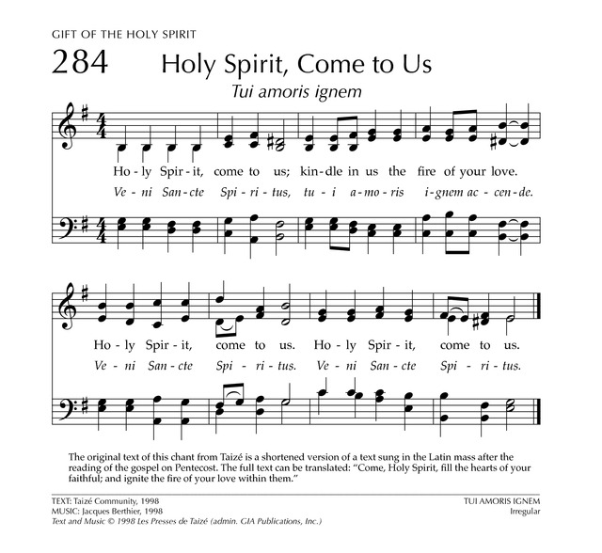

Prayers for Our Sister Church
To our petitions please respond: En yah Chee wū tah

Pray for our congregation projects building of the hall, evangelism and the attendance of the people in our church services.
Response: En yah Chee wū tah

We have our Parish Minister Rev. JCM Mhango involved in an accident in his house and he had his ankle broken. Please pray for him to have a speedy recovery as you can see from the photo. Response: En yah Chee wū tah

We ask you to pray for our nation, Malawi; we have economic challenges, politically we are at a stage where we need Divine intervention and pray for our corruption free Malawi. Also our youths are behaving abnormally and indulge in bad behaviors.
Response: En yah Chee wū tah

Prayers of the People/Lord’s Prayer

Our Father who art in heaven, hallowed be thy name.
Thy Kingdom come, thy will be done, on earth as it is in heaven.
Give us this day our daily bread;
and forgive us our debts, as we forgive our debtors;
and lead us not into temptation, but deliver us from evil. For thine is the kingdom, and the power and the glory, forever.

Final Song (138)
“Holy, Holy, Holy! Lord God Almighty”

Blessing and Sending

Postlude
We are glad you chose to spend your Sunday morning with us, and we encourage you to return!

Children of all ages are welcome in worship. Children’s worship materials are available from the book cart. A Cry Room is located at the back of the sanctuary.

If anyone would like to share over the summer months by singing, or playing an instrument, or a reading, please contact Greta Johnson (402-440-0938).

The Deacon’s Mission Giving Project for July is
Blessings In A Backpack. Blessings in a Backpack partners with America to ensure impoverished elementary school children are fed on the week-ends throughout the school year. Our local chapter of Blessings in a Backpack feeds 250 students in five elementary Schools each week. For more information, check out the bulletin board in the narthex.

Birthdays

Cathy McClary 8/01
Marlin Jones 8/03
Kaydance Brown 8/05
Pastor Brian 8/06
Eli Johnson 8/07
Carrie Wells 8/07
Kathy Sateren 8/08
Sandra Chisesele 8/12
Ryan Praeuner 8/12
Doc Walter 8/13

Anniversaries

Pastor Brian & Linda Johnson 8/08
Prayers for God’s Children

For healing and pain relief for those living with physical and emotional pain and for their families and friends

For our members who are home-bound or in nursing facilities.

For our mission partners.

For the men and women serving in our armed force

This Week at First Pres

Today: 10:00 AM – Worship
Monday: 8:30 AM – 10:00 AM N/A (fellowship hall)
6:30 PM – Session
Tuesday: 8:00 PM – 9:30 PM N/A (fellowship hall)
Wednesday: 8:30 AM – 10:00 AM N/A (fellowship hall 2:00 PM – Bulletin Information Deadline
Thursday: 8:30 AM – 10:00 AM N/A (fellowship hall)
5:30 PM – 7:00 PM TOPS (fellowship hall)

Next Sunday at First Pres
10:00 AM – Worship

Elders Deacons
Class of 2022 Class of 2022
Teri Wendel, Christian Ed. Kerry Richter
Jake Cox, Properties Karen Reimer
Duane Severson, Finance Greg Wendel, Secretary
Class of 2023 Class of 2023
Dennis Sateren, Missions Linda Douglas, Co-Moderator
David Unkel, Personnel Ann Letheby, Treasurer
Barb Beckmann, Worship/Cong. Class of 2024
Class of 2024 Mark Johnson, Co-Moderator
Kathy Naranjo, Worship/Cong. Sherry Johnson
Linda Cox, Clerk of Session Jayne Mtika

Elders of the Month – Dennis Sateren & Kathy Naranjo
__________________________________________________________2022 YTD Financials - through April 30th, 2022
Receipts $55,282.54 - Disbursements $63,931.79 = Net ($8,649.25)
Last Sunday Attendance 34

Worship Leaders & Staff

PASTOR Rev. Brian Johnson
MUSIC DIRECTOR Greta Johnson ORGANIST Steve Reinke
SOUND TEAM Joe Mtika, Barb Beckman
PRAISE TEAM Kim Rusk, Joe Mtika
LAY READER Ann Letheby

Credits: “Amazing Grace (My Chains Are Gone” by Chris Tomlin; “Here I Am, Lord” by Dan Schutte
is used under CCLI license #1820283.

Office hours: 9 am to 1 pm Mon.
9 am to 4 pm Tues. – Thur.
9 am to 1 pm Fri.
or other times by appointment

E-Mail: FirstPresB@ConPoint.com
Website: firstpresnorfolk.com
‘Like’ us on Facebook: First Pres – Norfolk, NE

